2021: THE VISION ONE YEAR LATER

By Tracy E. Antoine

AUGUST 27, 2020
This date marks the one- year anniversary of the devasting Category 3, Hurricane Laura. She made landfall in Cameron, Louisiana before ripping through Southwest Louisiana. In her wake she left behind six deaths and a ninety-seven percent structural damage index.
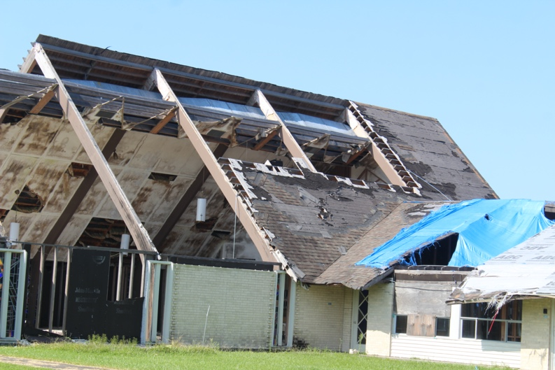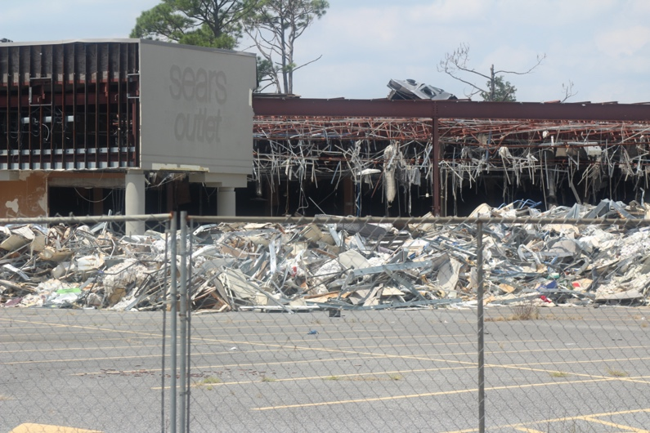
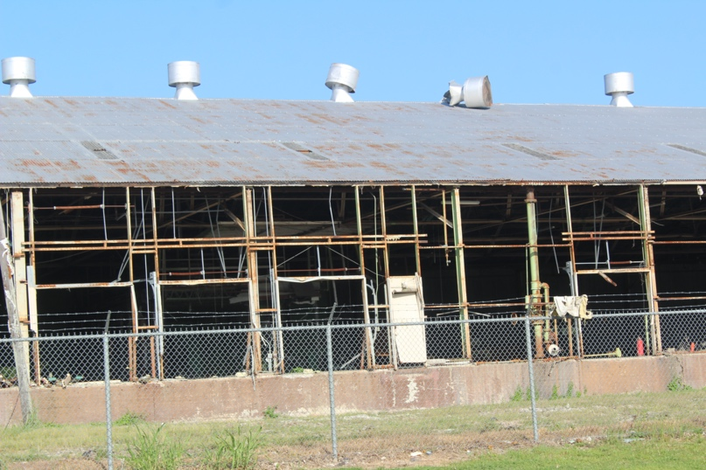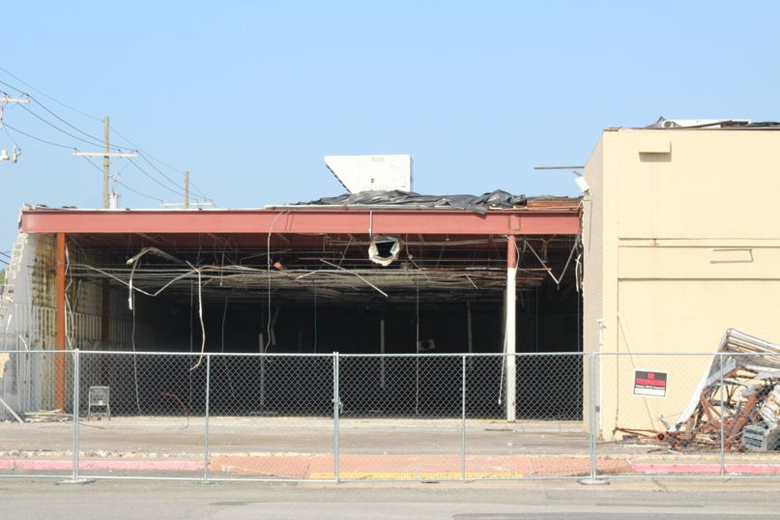

The progress to rebuild the cities of Southwest Louisianan has been a slow and frustrating process. After, issues with scamming contractors, debris, and drainage issues, alarming new COVID cases, and other natural disasters, we are left with the question, “will Southwest Louisiana be able to sustain a healthy living environment, if hit with another major hurricane?”
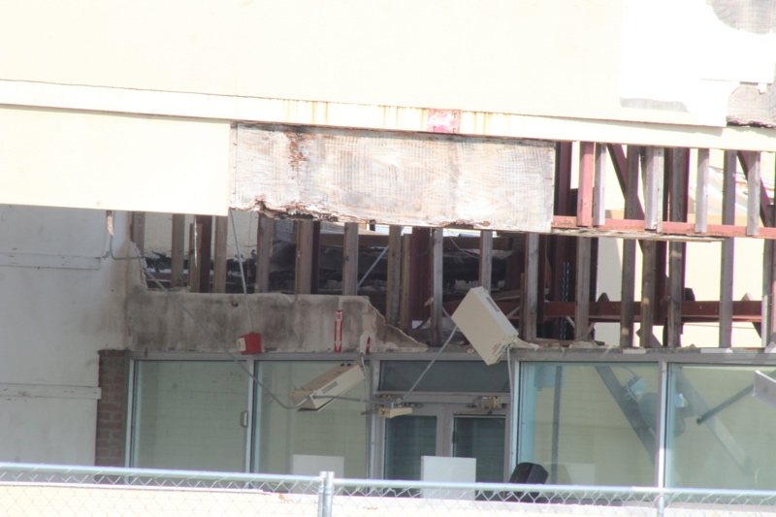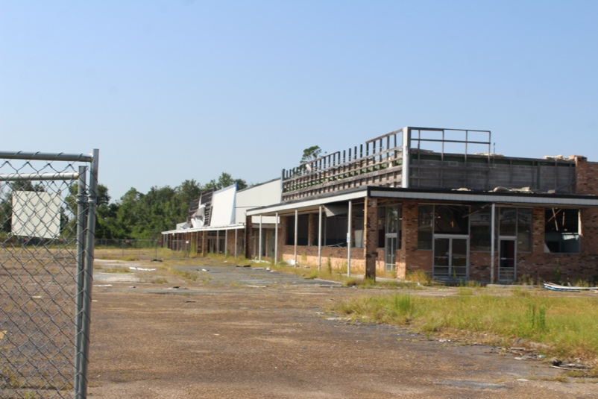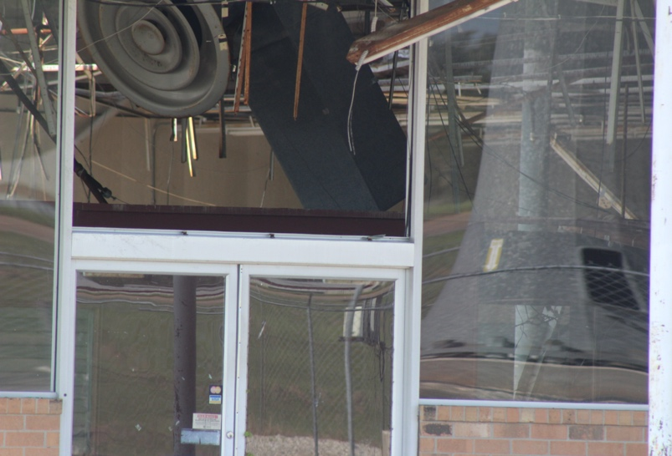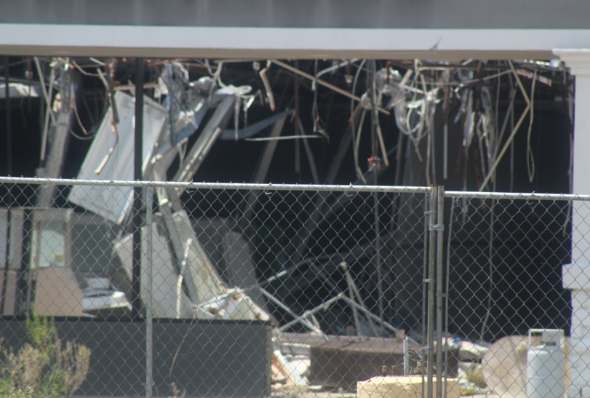

As I drove around the city of Lake Charles, revisiting some of the areas I photographed after Hurricane Laura. There has been little or no improvement to most of the city. Now faced with yet, another storm threat, what will be left of the Gulf Coast, after another record-breaking hurricane season.

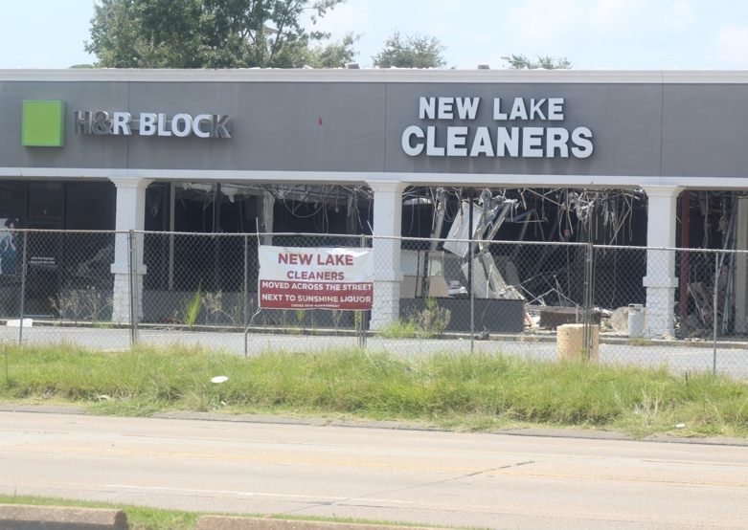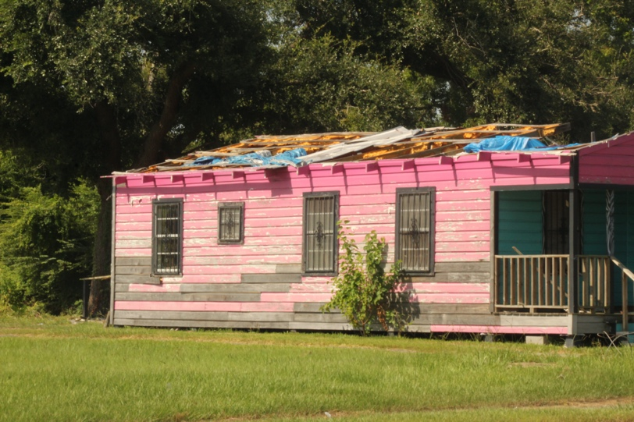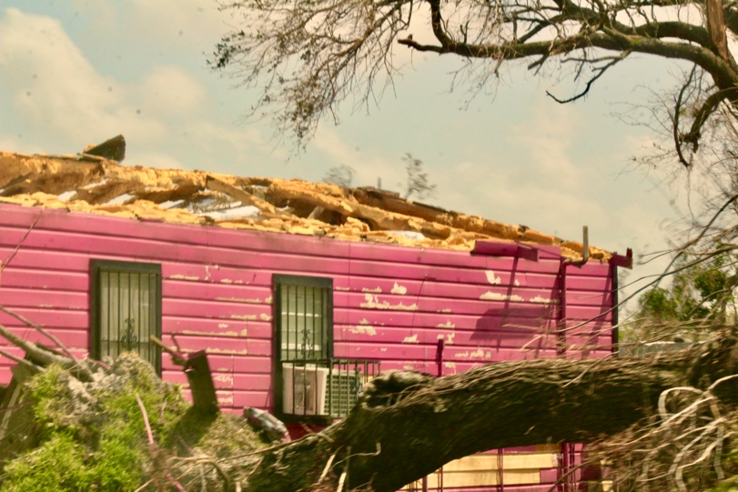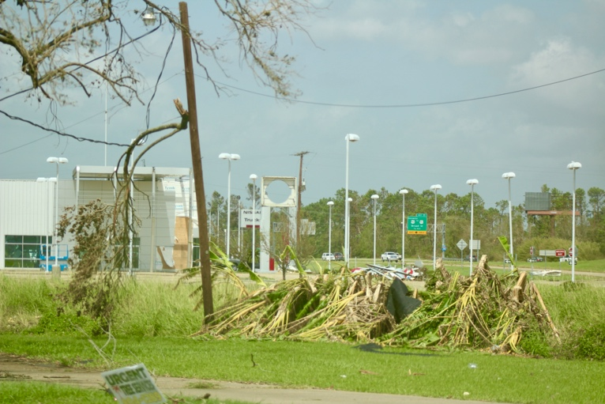

While the Gulf coast braces for another storm, The TEA Firm is dedicated to keeping the residents of South Louisiana and Southeast Texas, up to date with weather developments, and will continue in the weeks and months to come to shed light on the economic, mental health, COVID-19, and other issues that are detrimental to the rebirth of Louisiana and the Gulf coast.

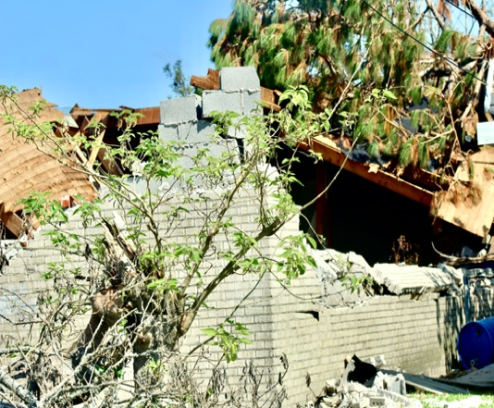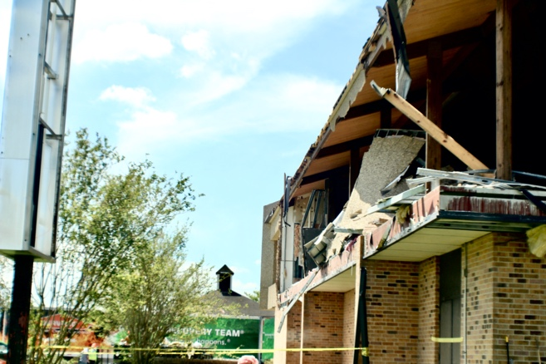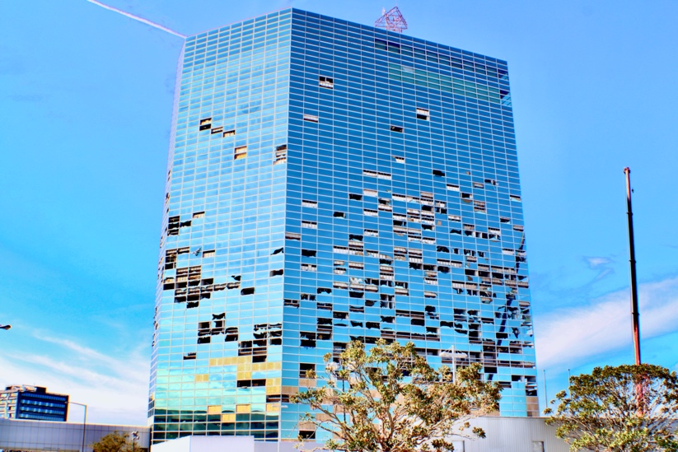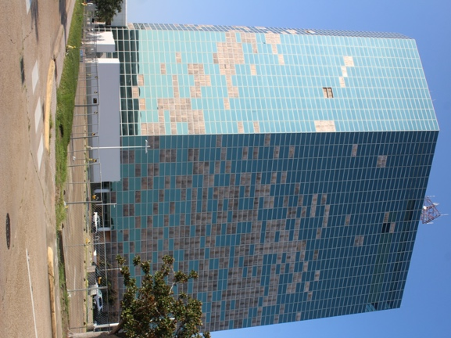
© 2020,2021 Lake Charles, one year after Hurricane Laura
PHOTOS by Tracy E. Antoine Photography

For more Stories that Matter, visit www.tracyeantoine.wordpress.com

